The Summit Story-Analytical Study of Himalayan Expedition (2020-2024)

1. Project Overview and Objective
This project involves cleaning, transforming, and analysing expedition-related data using Excel and developing an interactive Power BI dashboard to uncover meaningful insights about climbing patterns, peak characteristics, seasonal trends, Gender wise success and expedition success rates
The main objective is to apply data preprocessing techniques in Excel and create an interactive Power BI dashboard that visualizes key expedition metrics, helping users understand success trends, peak difficulty, climber demographics, and overall expedition performance for informed decision-making

2. Data Sources

Data set Link-Free Sample Dataset Download - Himalayan Expeditions - Maven Analytics | Build Data Skills, Faster
- Source Description and Timeline: Maven Analytics (2020-2024)
- Domain:Expendition- The Himalayan Database

3. Problem Statement
- To study the distribution of climbers by nationality, age, and gender to understand participation trends and demographic patterns
- To assess yearly trends in expeditions to understand the impact of climate, season, and peak popularity over time.
- To identify the countries and teams contributing most to successful Himalayan expeditions.
- To visualize overall expedition performance metrics through interactive Power BI dashboards for better decision-making and insights.

4. Attribute (Column /Features) Details:
Attribute Name | Data Type | Description
Peak_Name | String (Text) | Name of the Himalayan peak attempted.
Height_m | Numeric (Integer) | Elevation of the mountain in meters.
Country | String (Text) | Country where the peak is located.
Expedition_ID | Integer / String | Unique identifier for each expedition.
Year | Numeric (Integer) | Year in which the expedition took place.
Season | Categorical | Season during which the expedition occurred (Spring, Summer, Autumn, Winter).
Team_Name | String (Text) | Name of the team or expedition group.
Leader_Name | String (Text) | Name of the leader of the expedition.
Climber_Name | String (Text) | Name of the climber participating in the expedition.
Gender | Categorical | Gender of the climber (Male/Female).
Nationality | String (Text) | Country of origin of the climber.
Age | Numeric (Integer) | Age of the climber during the expedition.
Success_Status | Categorical | Indicates whether the expedition was successful (“Yes”/“No”).
Summit_Date | Date | Date on which the summit was reached.
Duration_Days | Numeric (Integer) | Number of days taken to complete the expedition.
Oxygen_Used | Categorical | Whether supplementary oxygen was used (“Yes”/“No”).
Total_Members | Numeric (Integer) | Total number of members in the expedition team.
Total_Summiters | Numeric (Integer) | Number of members who successfully reached the summit.

5. Tools & Technologies
- Excel: Data cleaning, transformation, and Pivot Tables.
- Power BI: Data modelling, DAX calculations, visualization, and interactive report creation.

6. Data Pre-Processing (Excel / Power Query)

Tasks Performed:
- Data Cleaning & Transformation: Removed duplicates, handled missing values, standardized formats, and created calculated fields.
- Filtering & Sorting: Organized data to focus on relevant records.

7. Data Modelling and DAX (Power BI)
- Data Model: Established relationships between tables, defined cardinality, and created lookup tables where necessary.
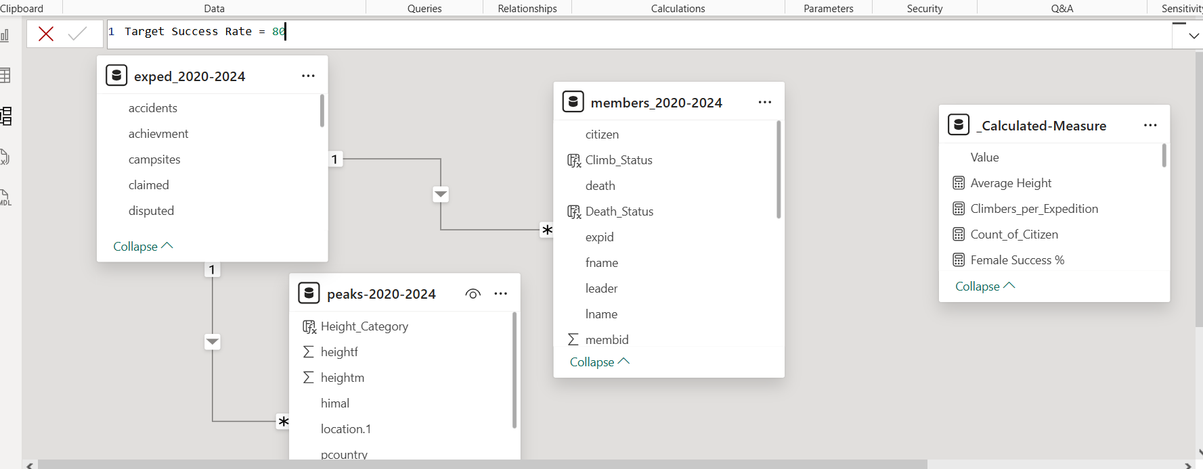
- Calculated Columns & DAX Measures: Implemented DAX formulas for key metrics,
Measure Name | Formula / Logic (Description) | Purpose / Insight
Total Expeditions | COUNTROWS('Expedition') | Calculates the total number of expeditions conducted.
Successful Summits | CALCULATE(COUNTROWS('Expedition'), FILTER('Expedition', 'Expedition'[Success_Status] = "Yes")) | Counts the total number of successful summit expeditions.
Success Rate (%) | DIVIDE([Successful Summits], [Total Expeditions], 0) * 100 | Calculates the success percentage of expeditions.
Total Summiters | SUM('Expedition'[Total_Summiters]) | Calculates the total number of individuals who reached the summit.
Total Members | SUM('Expedition'[Total_Members]) | Total number of climbers who participated in all expeditions.
Male Climbers | CALCULATE(COUNTROWS('Climber'), FILTER('Climber', 'Climber'[Gender] = "Male")) | Counts total male participants.
Female Climbers | CALCULATE(COUNTROWS('Climber'), FILTER('Climber', 'Climber'[Gender] = "Female")) | Counts total female participants.
Highest Peak Height | MAX('Peak'[Height_m]) | Identifies the tallest mountain in the dataset.
Lowest Peak Hight | MIN('Peak'[Height_m]) | Identifies the shortest mountain in the dataset.
Average Height of Peaks | AVERAGE('Peak'[Height_m]) | Computes the average height of all peaks.
Country-wise Success Count | CALCULATE([Successful Summits], ALLEXCEPT('Expedition', 'Expedition'[Country])) | Shows number of successful expeditions by country.
Overall Performance Gauge | DIVIDE([Successful Summits], [Total Members], 0) | Used in gauge chart to represent expedition success efficiency.  Climbers_per_Expedition = COUNTROWS(RELATEDTABLE('members_2020-2024'))  Number_of_Expendition = COUNTROWS('exped_2020-2024')  DISTINCTCOUNT: this function is used to count the unique data within the row.  Total_Peak = DISTINCTCOUNT('peaks-2020-2024'[peakid])  Unique_Name = DISTINCTCOUNT('members_2020-2024'[fname])  Calculated Colums:  Oxygen_used = IF('members_2020-2024'[mo2used] =TRUE(),"Used O2","No O2")  Death_Status = IF('members_2020-2024'[death]=TRUE(),"Died","Survived")  Nationality_Group = SWITCH(TRUE(),'members_2020-2024'[citizen]IN{"Nepal","India","Pakistan"},"South Asia",  'members_2020-2024'[citizen]IN{"USA","Canada"},"North Ameraica",  'members_2020-2024'[citizen]IN{"France","UK","Germany","Italy"},"Europe","Others")

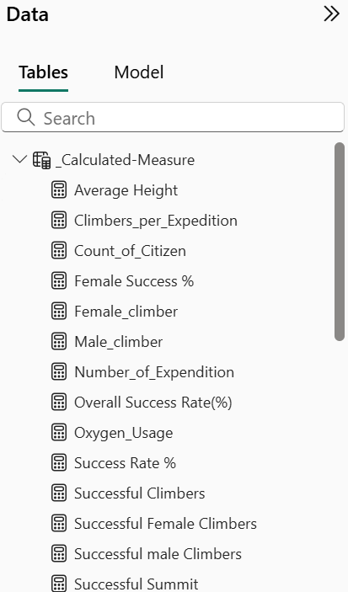
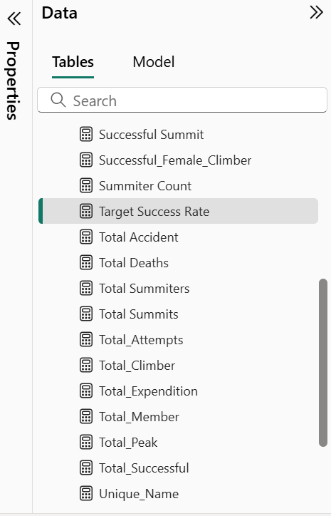
Created Calculated Columns:
- Climb Status
- Death Status
- Height Category
- Nationality_Group
- O2_Category
- Oxygen Used

8. Analysis and Visualizations (Power BI)

Dashboard Features:
- Multiple Visualizations based on problem statement: Bar charts, line charts, pie charts, cards, and tables to communicate insights. (List Out)
- Make your Report interactive Layout using Button, Filters and slicers
- Bookmarks, Clear Titles for each visuals & Labels is must.
- Create a consolidated Report /Dashboard.
SCREENSHOT OF DASHBOARD /REPORT
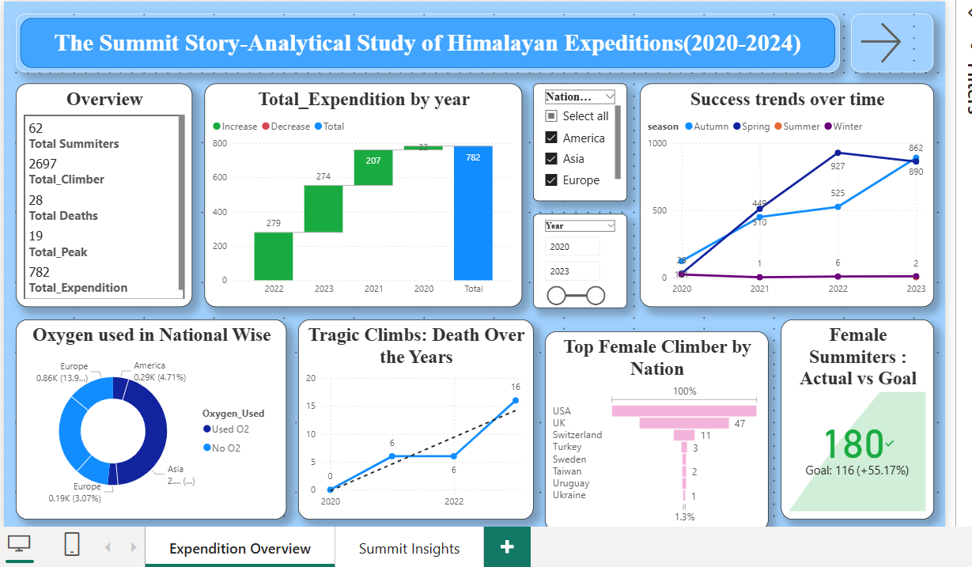
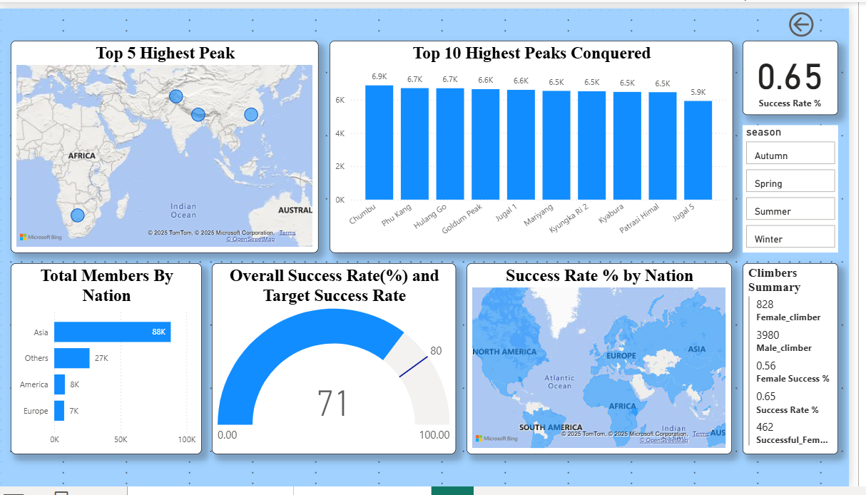

9. Insights & Conclusions

Key Findings
- The overall expedition success rate is moderate, indicating varying difficulty across peaks and routes.
- Nepal hosts the majority of successful summits, followed by India and China, highlighting its dominance in Himalayan expeditions.
- Peaks above 8,000 meters show significantly lower success rates, emphasizing the impact of altitude on outcomes.
- Male climbers participate in higher numbers, but female climbers show a relatively better success ratio.
- The spring season records the highest number of successful expeditions, showing favorable weather conditions.
- The average expedition duration and cost rise sharply for higher-altitude peaks.
- Teams using supplemental oxygen exhibit higher summit success compared to those who did not.

Descriptive Insights
- Total expeditions conducted: [Measure: Total Expeditions]
- Total successful summits: [Measure: Successful Summits]
- Average expedition duration: [Measure: Average Expedition Duration (Days)]
- Average cost of expedition: [Measure: Average Cost (USD)]
- Most frequently attempted peak: Mount Everest
- Country contributing the most climbers: Nepal

Diagnostic Insights
- Success rates decline significantly for peaks above 7,500 meters, indicating physical and environmental challenges.
- Weather conditions and seasonality are the most influential factors behind expedition outcomes.
- Failure rates are higher for teams with fewer members, suggesting experience and teamwork matter.
- Oxygen usage shows a strong correlation with higher success — especially above 8,000 meters.

Predictive Insights
- Based on historical data, expeditions attempted in Spring and Autumn have a higher probability of success.
- Teams from countries with prior Himalayan experience (like Nepal and Japan) are more likely to succeed.
- Climbers aged between 25–40 years tend to perform best, indicating optimal physical and endurance levels.
- Peaks with established routes and prior successful records show improved chances of future success.

Prescriptive Insights
- Encourage climbers to plan expeditions during the Spring season for improved success and safety.
- Promote team-based climbs with adequate member strength to enhance coordination and safety.
- Recommend supplemental oxygen usage for peaks above 7,500 meters to increase summit probability.
- Use historical expedition data to guide future planning, route selection, and risk management.
- Focus on training and experience-building for climbers from less successful countries to improve global participation balance.

The integration of Excel and Power BI proved effective for end-to-end data analysis, from raw data to visual reporting.

